# Write Up – Technical Exercise

## Pre-Requisite

* Install MSMQ in the local computer
* Go to Control Panel
* Click on Turn Windows Feature On/Off. Make sure all below options are checked. Click OK

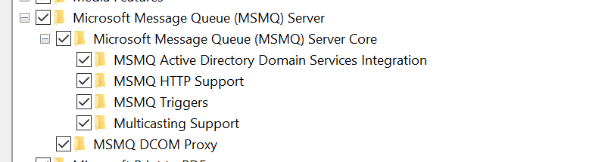

* After this is setup, please start debugging Publisher and then start debugging the SubscriberA and SubscriberB projects respectively.

## Publisher

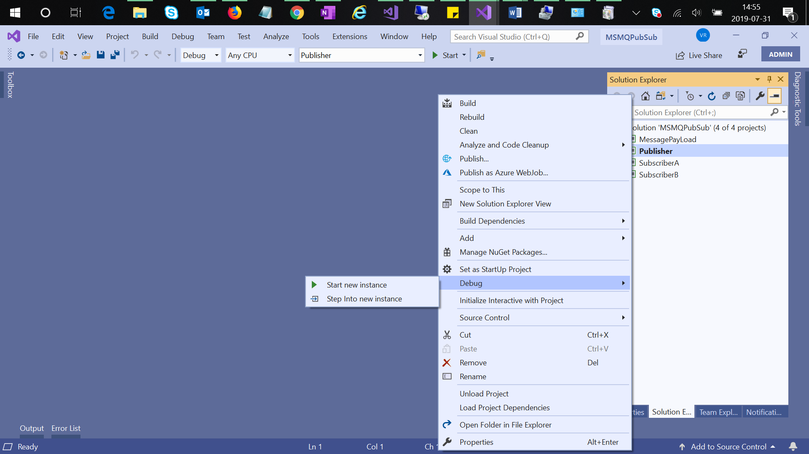

## Subscriber A

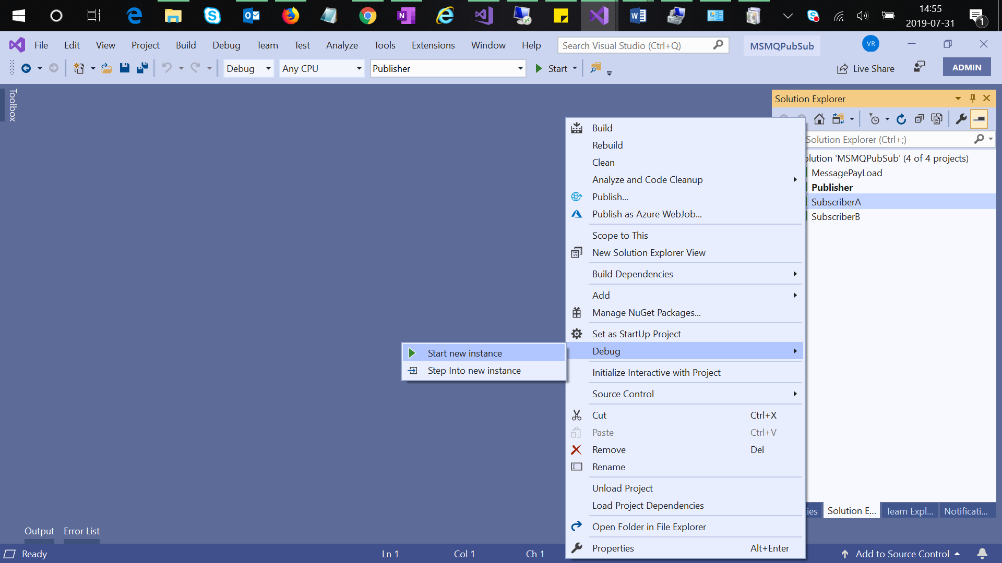

## Subscriber B

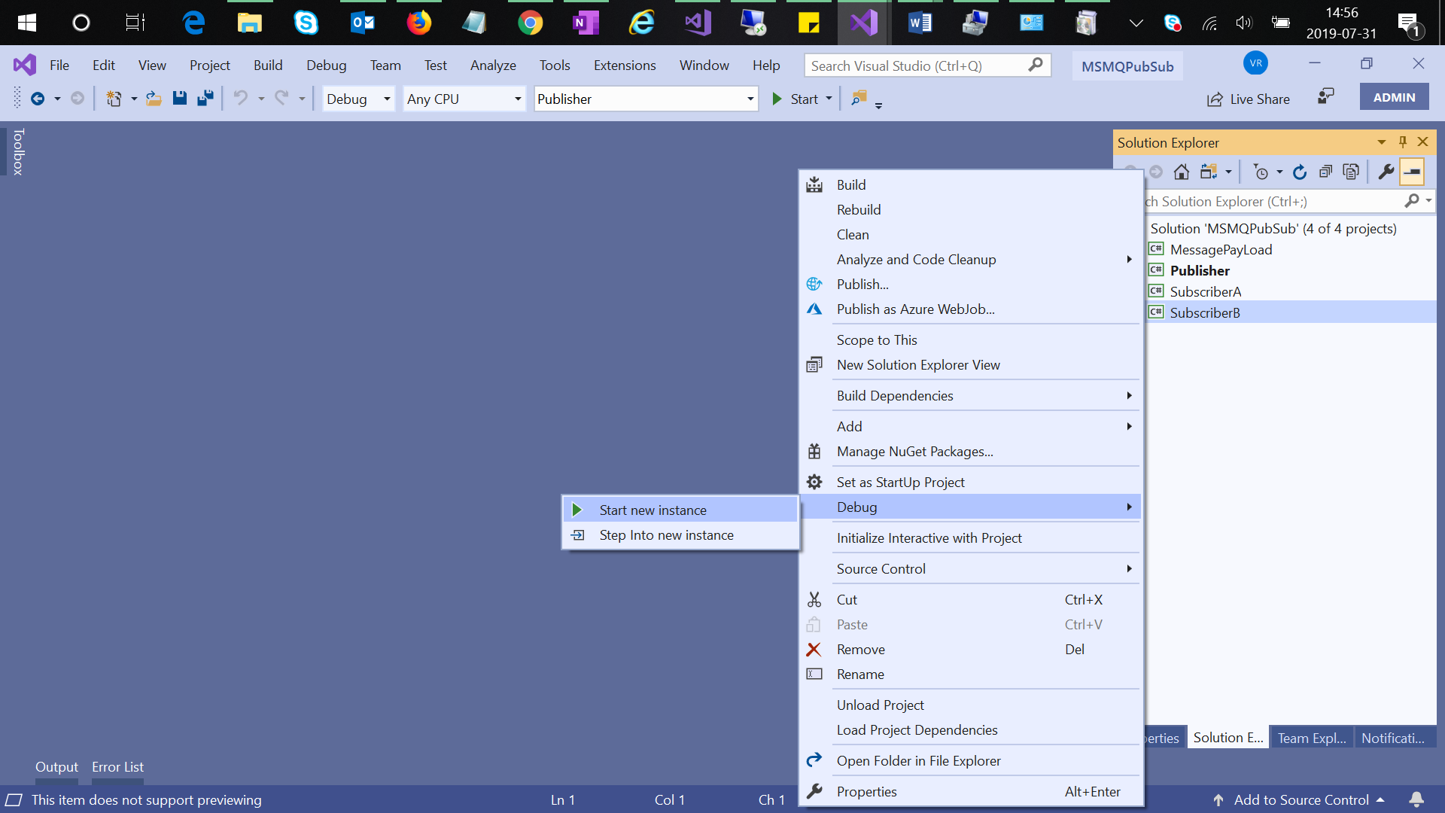

## Publisher

Look for prompt in the publisher console after started Debugging – Enter a message to transmit.... Press x to exit

Enter a message to transmit to the MSMQ by transforming it into an XML format

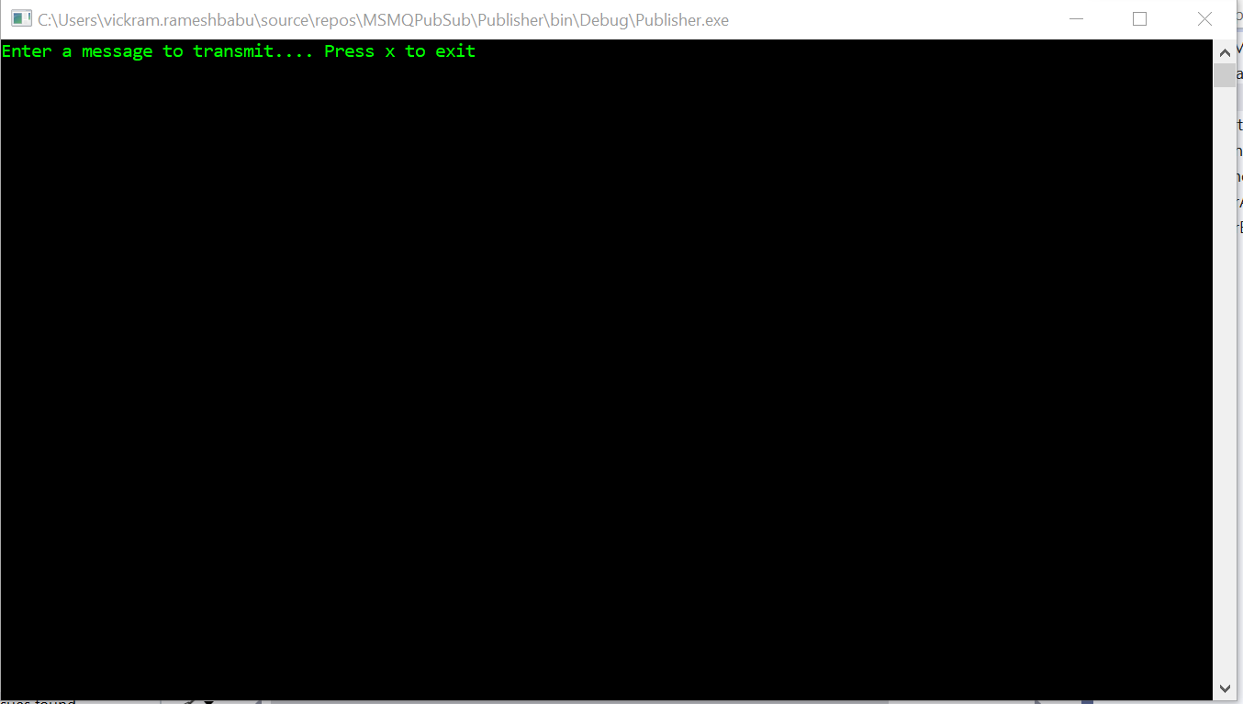

## Subscriber

At the subscriber end, we parse the XML based content and show it in the console as output.

Look for prompt in the subscriber console after started Debugging – Hit S to subscribe to Publisher at any time... Press X to exit

Hit S and press enter to see messages

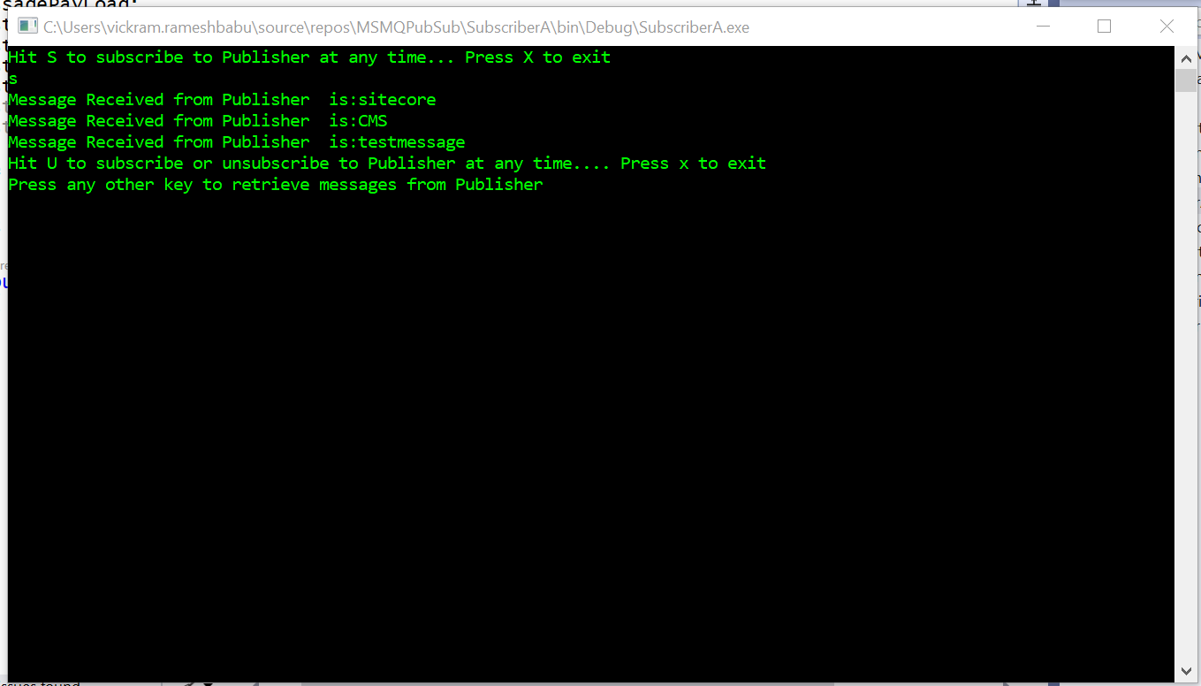

Hit U after receiving the messages to unsubscribe from the publisher.

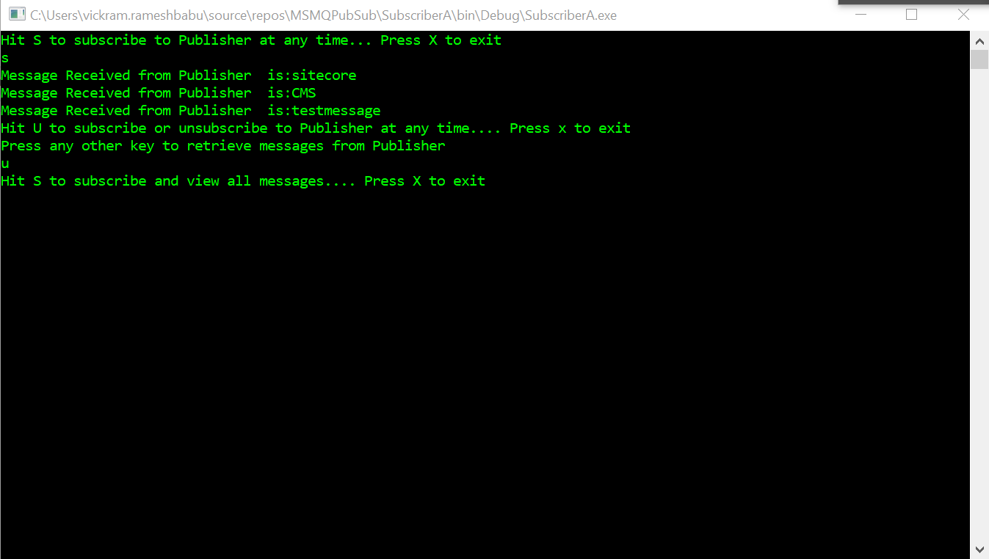

## Publish and Subscribe Messages – Final Outpu

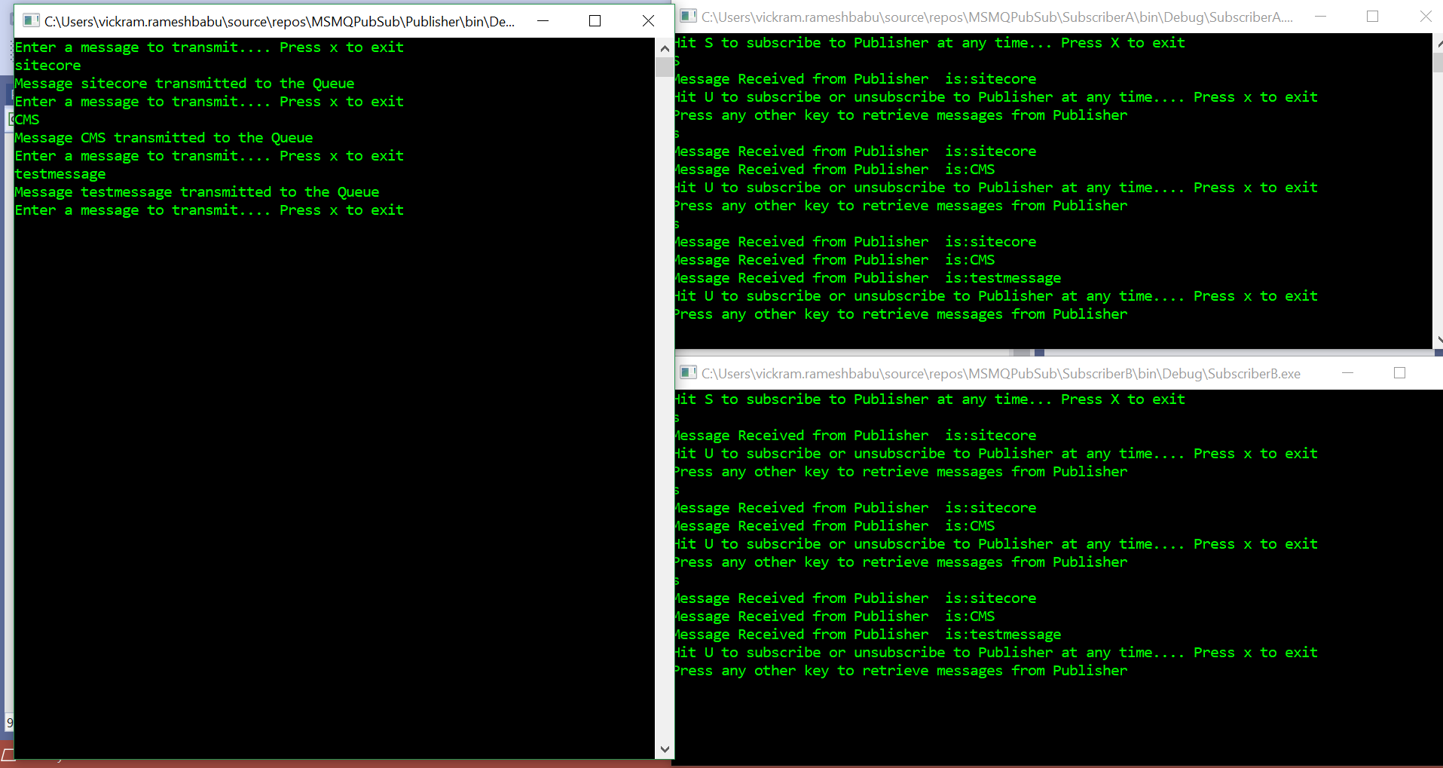

## Future Work

* Making the project scalable to different types of message payload types
* Making the messages displayed at subscriber end at real time without user interrupt.